Stray USAAF bombs cause disaster

5th April 1943: Belgium's worst loss of life in a single incident during the entire war
APR 5

SAVE |  | ▷ LISTEN

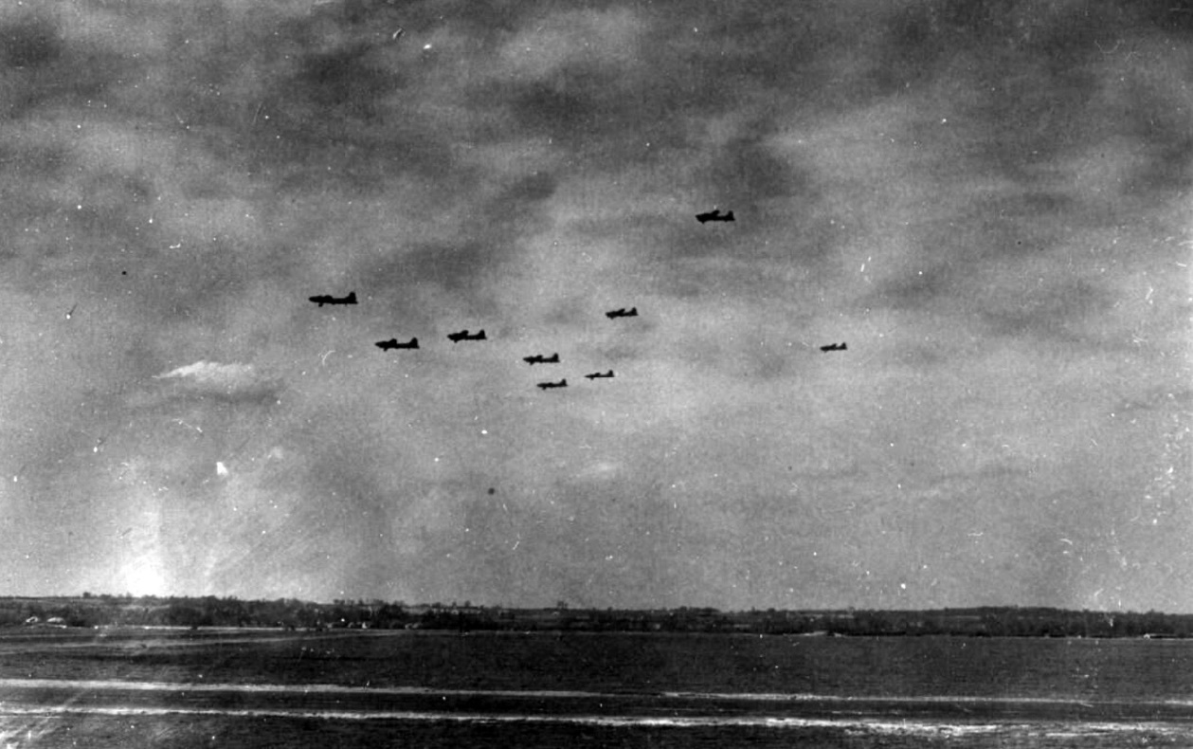
‘Night and Day air blitz of enemy continues. "Forts" smash Axis factories at Antwerp raid carried out by crews who took part in Paris raid previous day.’
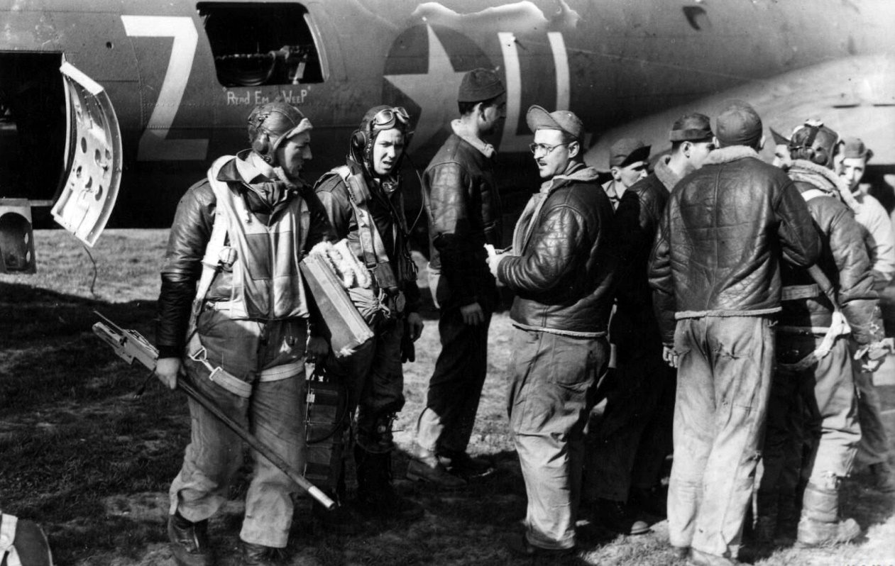
Crews arriving back after the Antwerp raid at their home base "somewhere in England"
The Public Relations office of the 8th Air Force in Britain released a group of images on the 6th April 1943, highlighting the success of raids carried out over the previous few days.
Night and Day air blitz of enemy continues. "Forts" smash Axis factories at Antwerp in Raid carried out by crews who took part in Paris raid previous day. The greatest air offensive in history is being carried out by the Anglo-American air forces.
For 72 hours bombs have been crashing down on Hitler's Europe in the West almost nonstop. Axis Factories, ports and shipping have felt the weight of allied bombs. On Sunday American Fortresses raided the Renault works at Billancourt, near Paris with telling effect.
On Monday the same crews took part in a smashing attacked on the Erla plane engine works at Antwerp, where Minerva car engines used to be made. In addition to the great damage inflicted by the heavy weight of the bombs a number of German Fighters were shot down by the bombers.
One of the American Fortresses piloted by 1st Lieut Harold H Beasley of Andalusia, Alabama shot down four German fighters in the Paris raid and another one during the Antwerp Raid. ¹
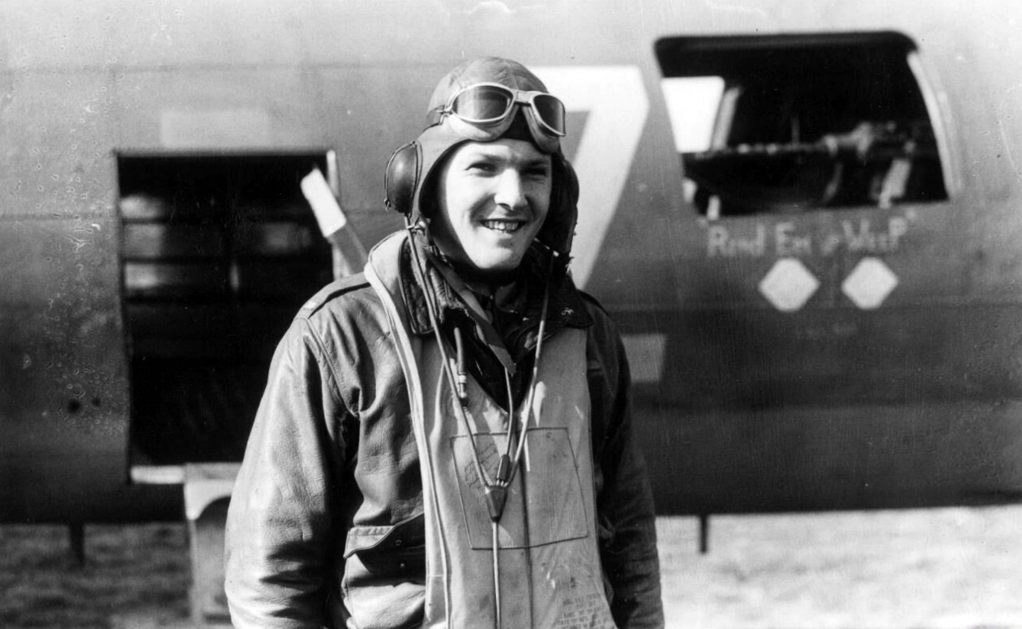
Lieut Harold H Beasley of Andalusia, Alabama shot down four German fighters in the Paris raid and another one during the Antwerp Raid.
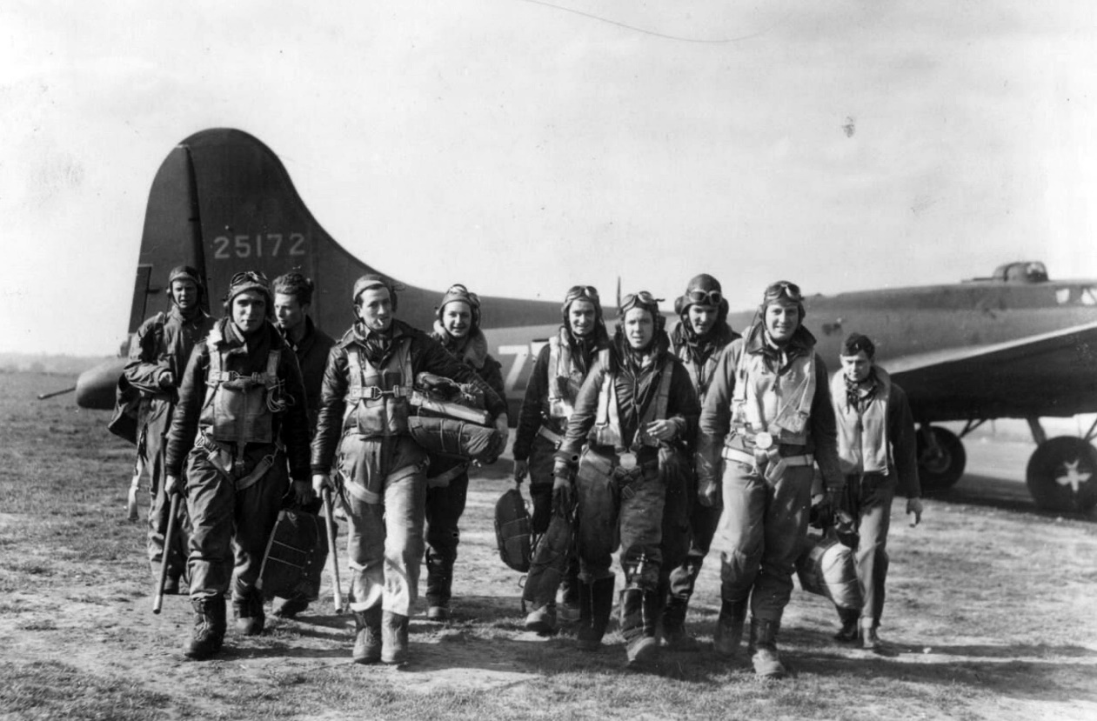
1st Lieut. Harold Beasley and his crew walking from their plane on their return from the Antwerp raid.
The main force is directed at the Erla aircraft factory and Erla engine works. 82 B-17's drop 245.5 tons of bombs at 1530 hours local.
On 5th April 1943 the USAAF VIII Air Force mounted an attack on Mortsel in Belgium, very close to the city of Antwerp. The target was the Erla motor works which had been taken over by the Germans to maintain Luftwaffe planes.
EUROPEAN THEATER OF OPERATIONS (Eighth Air Force) VIII Bomber Command Mission 50: 104 B-17's of the 1st Bombardment Wing are dispatched against industrial targets in the Antwerp, Belgium area. The main force is directed at the Erla aircraft factory and Erla engine works. 82 B-17's drop 245.5 tons of bombs at 1530 hours local.
We claim 23-8-4 Luftwaffe aircraft; we lose 4 to strong Luftwaffe fighter opposition; 13 aircraft are damaged. Casualties are 3 WIA and 40 MIA.
Amongst the units taking part was the 303rd Bomber Group whose reports give a little more detail:
Seventeen aircraft bombed the primary target from 24,000 feet with 51 tons of 1,000-lb. H.E. M44 bombs. Slight, inaccurate, black flak was reported over Ostend, Ghent, Bruges, and Schouwen Island.
Enemy air opposition was moderate with 30 to 50 aircraft reported. They attacked from the Belgian coast to mid-channel enroute back. FW-190s, ME-109s, ME-110s, and JU-88s were seen in twelve encounters.
303rd BG(H) gunners destroyed three with one probable. Sgt. P.E. Henderson and S/Sgt. R.R. Peck each shot down an FW-190, Sgt. R.K. Sink shot down an ME-110 and Lt. W.V. Chamberlain had a probable on a Ju-88. In at least five instances, fighters bombed the formation. The bombs were accurate as to altitude and bursts were four times the size of flak bursts.
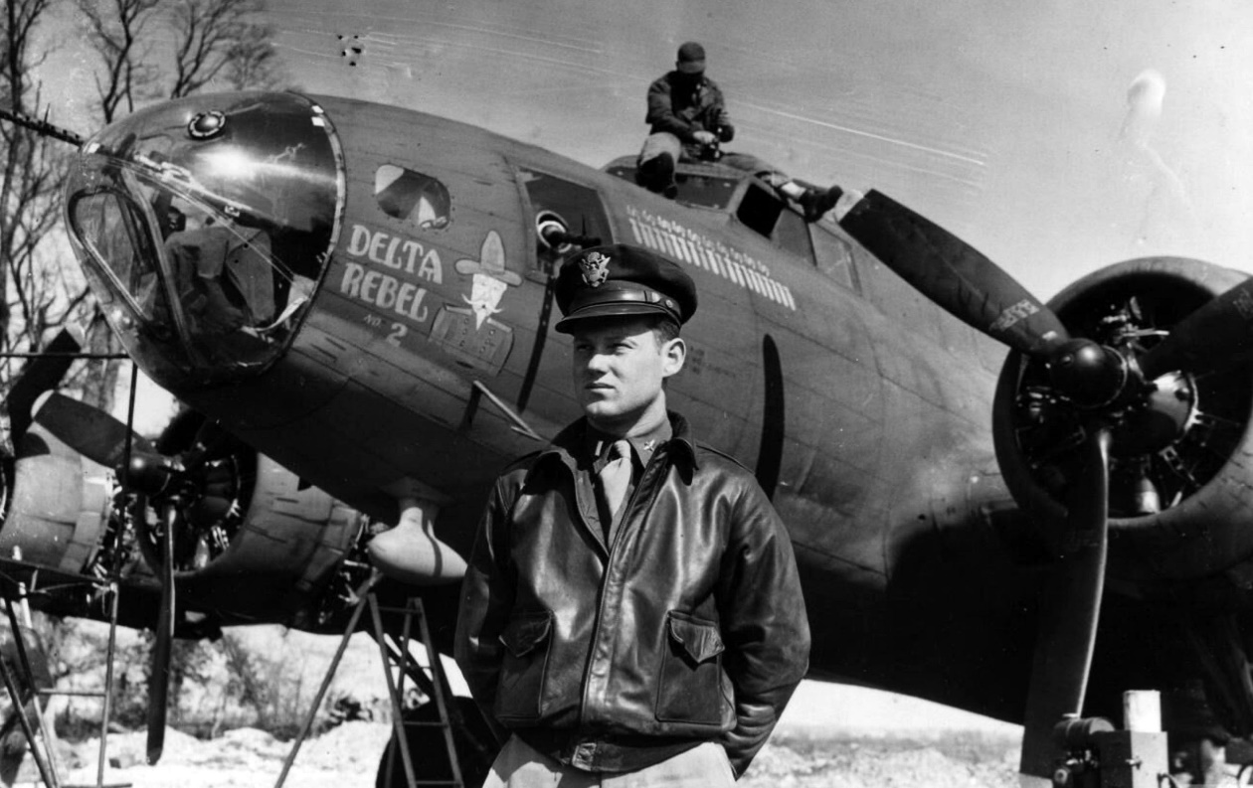
A Fighting "Rebel" of the United States Air Force. A successful veteran of the United States Army Air Force in the country in the Flying Fortress "Delta Rebel", which with its crew under Lieut. C.E. Cliburn, of Hazlehurst, Mississippi, has taken part in 22 daylight raids on enemy territory, including the recent attack on Antwerp. Eleven enemy fighters are claimed as "killed" by the Fortress gunners. Photo shows: Lieut. C.E. Cliburn, of Hazlehurst, Mississippi, standing in front of the Fortress "Delta Rebel" at an air station somewhere in England.
This was a fairly typical raid for the 8th Airforce at the time, flying without close fighter support the Flying Fortresses were expected to defend themselves against enemy fighters, although on this occasion, as the target was just across the English Channel, there was RAF fighter support most of the way:
Good Spitfire fighter coverage² was provided from the turning point to within twentyfive miles off Harwich. The pilot, Lt. Burch, remarked, "We were in formation until we hit the continent, when suddently a burst of flak knocked out our oxygen system. No sooner had this happened than an enemy fighter made a close attack and knocked out the No. 1 engine.
Knowing we couldn't stay in formation, I pulled out to head for home. Another FW- 190 came in and hit our No. 3 engine, but it didn't go out altogether. The No. 2 engine had its oil line shot out, but it kept running. Lt. Byron Butt, my bombardier, was just going to his bombsight when a 30 caliber came through the plexiglass near the sight and creased his forehead. Another inch and it would have gone through his head.
We were gradually losing altitude and we were prepared for anything. One Spitfire observed our plight and stayed with us until we were half-way over the channel and then left us believing we could make it back OK. When we finally had to land, we had one and one-half engines and a flat tire.
We were damned worried for a while, but glad to be back. One of my gunners, S/Sgt. R.M. Arnold, had a close one, too. Flak caught him in the face, but luckily, it didn't hurt him much." Lt. Burch made a perfect landing, despite the extensive damage to his B-17.
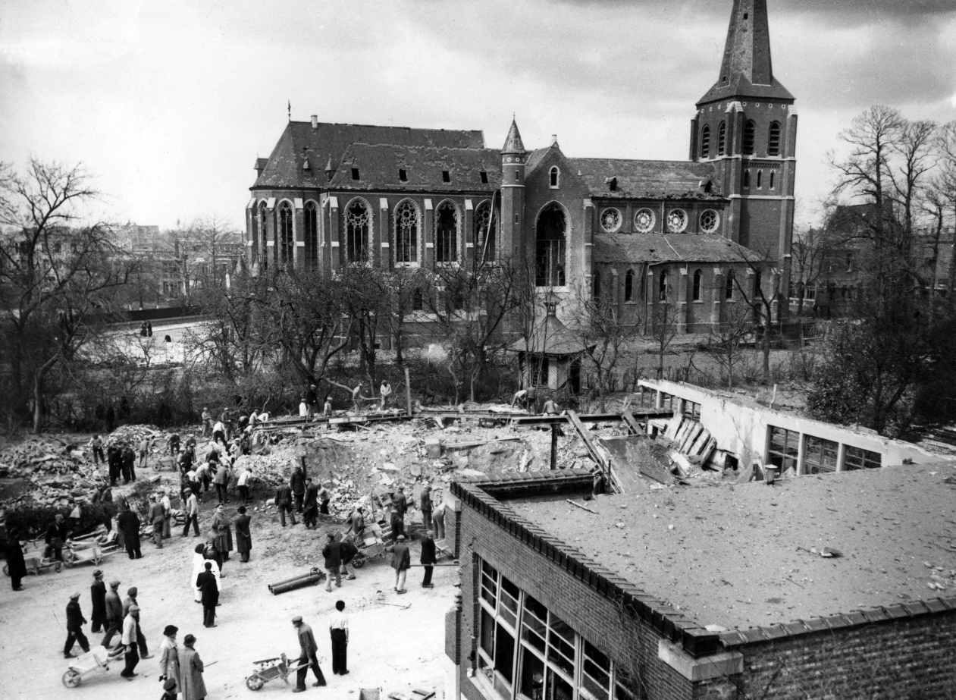
Damage in Mortsel after the raid in which more than one school received a direct hit
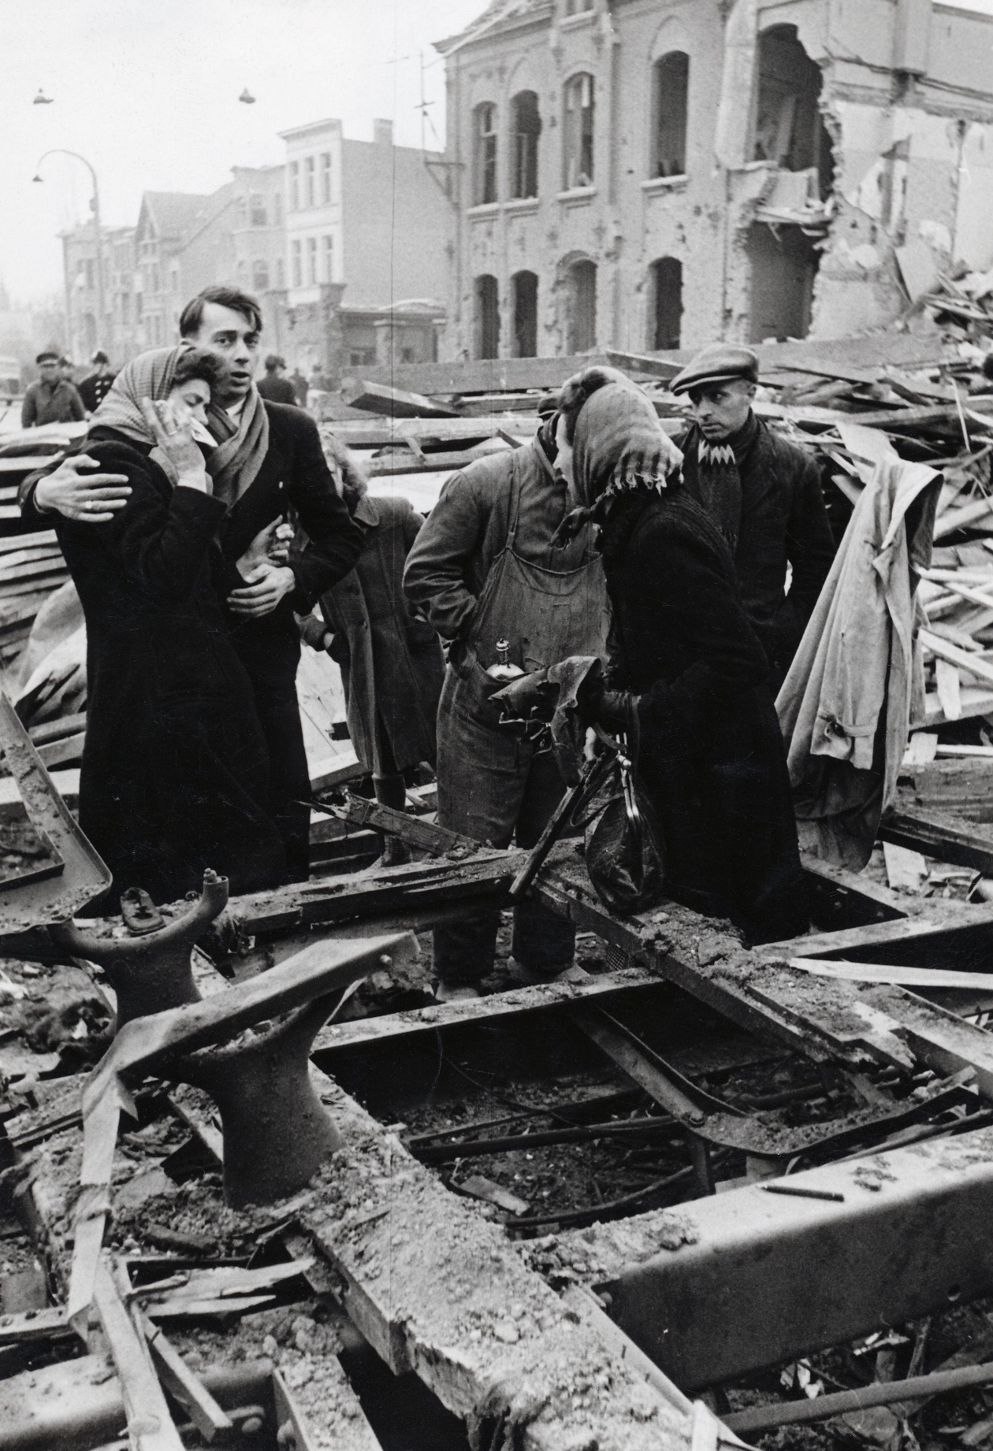
In just eight minutes 936 people were killed, including 209 children under the age of 15.
Only a few bombs hit the factory but these started fires which destroyed most of the facilities - and also caused heavy casualties amongst the civilian workforce.
It was the remainder of the 245 tons of bombs that were to cause widespread casualties in the town of Mortsel.
There was little warning of the raid and many people were on the streets. This partly accounted for the heavy casualties, but there was devastation across a wide area of the residential area of the town. In just eight minutes 936 people were killed, including 209 children under the age of 15 - more than one school received a direct hit. Over 1600 people were injured, 600 of these were classified as serious. It was Belgium's worst loss of life in a single incident during the entire war.
The funeral was never-ending. We stood with our school on either side, all sorts of trucks passing by. There were thousands of people. It took hours for that procession to reach the cemetery.
April 9, 1943, the day of the funeral³
Four days after the air raid, most of the 936 victims were buried. Until today, the countless white crosses remind us of the dead. The goodbye on that Friday morning was a national tribute. After a mass for ten missing in Antwerp cathedral, a procession left as far as Mortsel. The other victims were waiting in wooden boxes loaded on trucks on the Gemeenteplein. A ceremony was held under the direction of the cardinal. From there the procession continued with all the victims to the cemetery.
Witnesses state:
"They were in coffins as thin as orange containers. There were gaps between them so you could see those people lying there. They were being loaded onto trucks, because all the hearses were already in use.
"The funeral was never ending. We stood with our school on either side, all sorts of trucks passing by. There were thousands of people. It took hours for that procession to reach the cemetery."
"A large crowd was waiting in front of the square. Whenever a truck stopped at the gate, a master of ceremonies came. He was wearing a black suit with a top hat. He had a list and read the name of the person each time. which was unloaded. So the family could follow the body to the grave. "
1
From the Press release accompanying pictures issued on 6th April 1943.
2
Mission Report of the 303rd Bomber Group
3
From a modern memorial plaque in the town of Mortsel

